Gathering Information Realtime and Anywhere (GIRA)

Aciek Ida Wuryandari*1 and Ary Setijadi Prihatmanto*2

*School of Electrical Engineering and Informatics

Bandung Institute of Technology, Ganesha Street 10, Bandung 40132, Indonesia

1aciek@lskk.ee.itb.ac.id

2Asetijadi@lskk.ee.itb.ac.id

Abstract— **By using mobile technology, Content Based Image Retrieval (CBIR), which combined with the Location Based Services, made an application called the Actual Mobile Guide Application for Tourist which can be used as a guide and actual real time for tourists and can also be used as alternative media to promote or ads from companies engaged in tourism, such as: hotels, restaurants, travel agencies and others. This application has the potential to be a killer application in the world of mobile application.**

**The application made is for the mobile handset with a low-end category that has very limited computing, so that its image recognition engine will be included in application server on the server side together with image matching engine, while at the client side (HP) will only be there interface to perform image capturing and sending images to a virtual application server and displays content of the object being targeted.**

**This application can be used as a medium of information that will be used by users to find out any information possessed by an object of tourism, building and others.**

Keywords— **Content Based Image Retrieval, Location Based Services, low-end mobile handset category.**

1. INTRODUCTION

Mobile applications on the present experience a significant development, includes innovative operating system, hardware and software in line with the progress of the internet. But will not have high economic value if not accompanied by analysis of the need for growth in other areas such as tourism. Indonesia as a developing country which has thousands of islands which have been exotic island – Bali, for example, to visit as many as 5.7 million foreign tourists during 2008. This business opportunity when analyzed over the country will increase foreign exchange. Viewed from the eyes of technology, the behavior of foreign tourists is the community to the needs of high Information Technology (IT).

IT and tourism is a new innovation in the country and is still rare in the world. This application uses the object catching techniques with mobile phones and recognition data processed by the server. With the result, foreign tourists will have no trouble when going to visit a tourist attraction. Simply can be summarized with the logo "Where am I? Where are you going? And, there is everything? ".

The technique used is markerless augmented reality has been implemented with the academic purposes by two foreign researchers, while the value for profit does not exist.

1. BACKGROUND

Actual Mobile Application for Tourist Guide is a markerless augmented reality-based applications and content based image retrieval (CBIR) combined with Location Based Services. Implementation is tailored to market segmentation.

Actual Mobile Application for Tourist Guide-based content based image retrieval (CBIR), which on this engine product image recognition, object matching engine and content are on the server side, while on a mobile handset (HP) just installed the client application to make the process of image capture and delivery image to the application server. This product is designed to accommodate low-end mobile devices.

Actual Mobile Application for Tourist Guide will be used as a medium of information to be used by users to find out any information possessed by an object of tourism, building and others, as we see in the picture below.

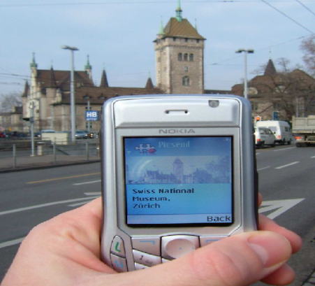

Fig. 1 Implementation markerless augmented reality for the introduction of the building

Other information can be obtained is the location of buildings or rooms in a building that was targeted. Besides these applications can also be used as an alternative medium for promotion or advertising object through feature recognition owned this application. As can be seen in the figure below.

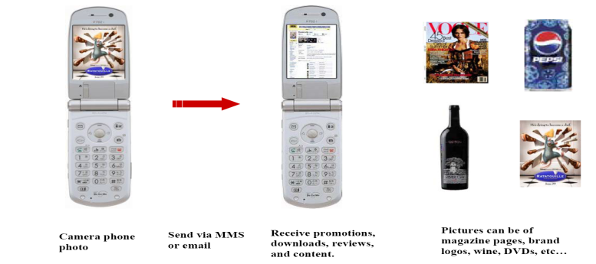

Fig. 2 Object recognition for advertising purposes

1. ANALYSIS AND SYSTEM DESIGN

Basic feature of Actual Mobile Application for Tourist Guide, as follows

* Image Capture
* Actual Object Recognition (Building, roads, rooms etc.)
* Object Matching
* MMS
* the features possessed by Markerless Augmented Reality
* Actual Advertising Services
* Nearest Object Searching (gas stations, ATM, Bank, Restaurant, Hospital), based on LBS

Top of Form

The excellent features are

* Actual Object Recognition (Building, roads, rooms etc.)
* the features possessed by Markerless Augmented Reality
* Actual Advertising Services
* Nearest Object Searching (gas stations, ATM, Bank, Restaurant, Hospital), based on LBS.

Augmented reality will be used as one of the information will be used by the user to ask where he is. Other information can be obtained is the location of buildings or other rooms.

Actual Mobile Application for Tourist Guide is a mobile application based markerless augmented reality that uses GPRS/3G/HSDPA network to connect its data. This application uses a client-server application architecture, where client applications installed on mobile communication devices.

On the client application, functionality is owned as follow:

* take pictures of targets,
* make the process of image recognition to generate the number of keypoint descriptor,
* sending images and keypoint descriptor,
* displaying information corresponding to the target image.

As for the server side, the application is installed on one or more application servers that are placed in co-location in a data center, both located on the mobile operators or the third party provider of data center services.

Owned application functionality on the server side are as follows:

* make the process of image matching using the NNS algorithm and its variants,
* generate the SQL file to make the process of querying information from the target image against the database server,
* to generate an XML file that contains information corresponding to the target image.

In this study, functional specifications need to be elaborated on the requirement specification (FRS), which aims to explain and describe the functionalities that must be owned by the application, which became the foundation for researchers in implementing and making this application. Besides this FRS will be the basis for the user in the process of User Acceptance Test (UAT).

This product consists of functional requirements include:

* validate LBS based on the nearest BTS,
* capture images from your HP camera and implement Difference of Gaussian,
* perform rotation invariant, scale and illumination changes in images,
* produce a key descriptor of the image taken with the camera,
* perform image matching with NNS algorithm,
* generate XML as the information on the nearest object,
* review the buildings highlighted by a camera phone,
* displaying public places around the object is highlighted, such as gas stations, hotels, restaurants;
* implement augmented reality technology, which means it can translate the image of the target object with another image.

Limitations of this application are as follows.

* This product uses augmented reality as a tool to display information for mobile phones that belongs to the category of low-end.
* This product uses the SIFT algorithm to match the highlighted image to that of the database.
* The product uses Java as the basis for making an application.
* This product uses the Symbian OS on mobile phones as a trial.
* This product uses the SIFT algorithm to perform image recognition and use the NNS algorithm in performing image matching.
* programming language used to create this application is a C + + and Java.

The application of this type are made for the category of low-end handsets, where all processes image recognition and image matching performed on the server side, while on the client side or on the HP users who only have an interface to make the process of capturing images, sending images and virtual displays content of the object target. More detail can be seen in the figure below.

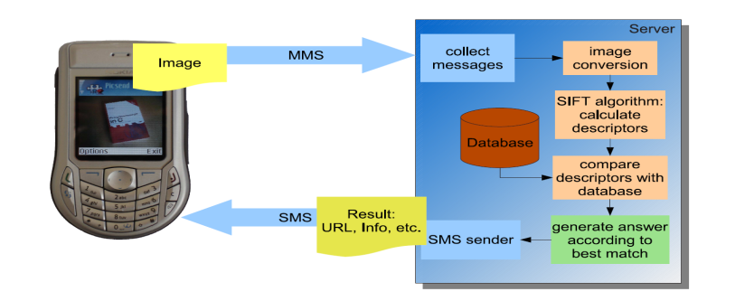

Fig. 3 The flow of the application process from the client side



Fig. 4 The flow of the application process from the server side

As for the process that occurs when the image recognition and image matching can be seen in the picture below.

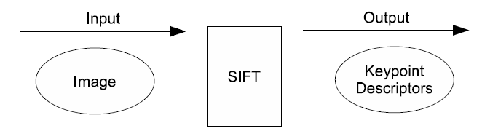

Fig. 5 Image recognition using SIFT algorithm on the client application (HP)

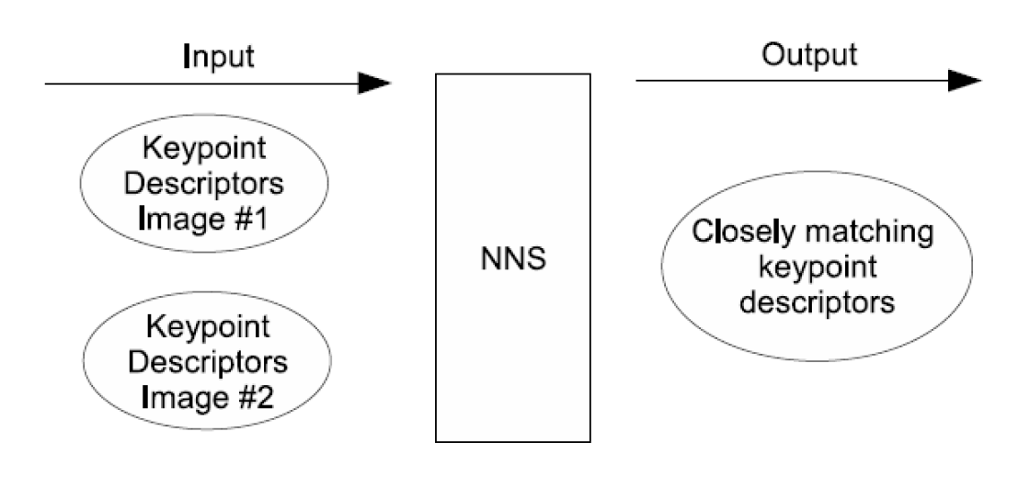

Fig. 6 Image matching using the NNS on the server side

Image matching process for HP that has a very good computational speed, the process of image matching and image recognition it can be done on the HP users, so the performance of mobile augmented reality can be achieved, where with the help of LBS, users download the first all keypoint descriptor for areas that are in current position. Then, after that application is based mobile augmented reality can be used in real time to recognition the building, room, nearest object searching and others.

Overall usage scenarios such as the following example. Users on the HP it has been installed application asks the desired content, for example: when the user is looking at a picture on a magazine tourist attraction, then she/he snapped the picture, after which the data is sent over the internet. That's when users are charging by cutting off the pulse. Furthermore, the portrait images that have been processed on the server and look for corresponding data, then sent to the user, the user will receive information such as name of the attractions, places of business, location, distance from the nearest object in 3D format such as augmented reality visualization.

Other examples, such as the user is located around the area attractions, and then she/he wants to find the nearest restaurant. Applications with specific input to find the closest distance, will get route path that must be passed along with the business. Overall process flow of the server and client side as shown below.



Fig. 7 The flow of the entire process from the server side and client

The technology and equipment used to develop this application are as follows.

* Technology: J2ME/Symbian Based Platform, Image Recognition, Image Matching, Network Programming.
* Development Tool: Netbeans, Carbide C++, Eclipse.
* Library: Symbian SDK, J2ME API, google map and google latitude SDK.
* Design Tool: Relational Rose, Microsoft Visio Drawing.

1. iMPLEMENTAtion

As a first step to achieving what has been described above, then made ​​a map, called Live Map City. Live Map City is a map of the entire building and the structure was mapped in a two-dimensional buildings in which public service vehicles moving according to the original movement.

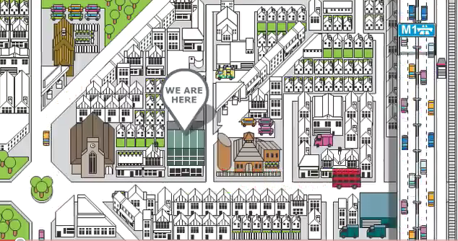

Fig. 8 Live Maps City

Various maps already exist, including the satellite map (photos directly from satellites), maps the flu, the greening of the world map, tourist map of the distribution plus photos, maps twitter / foursquare, trending topic maps, or map tracking. Among the many maps tracking maps for bike, car or motor vehicle which is partially owned by certain companies. It required a special map that can be seen tracking the entire vehicle, bicycle or human. This situation can of course be done at this time because they spread many smartphones already had GPS or vehicles that have been using similar equipment.

The map was created using two-dimensional building as above, where cars, motorcycles, and people can move within the map. The movement of cars, motorcycles, and humans are based on a cell phone registered in this web. Own buildings and vehicles are made so that the user can choose your own icon that will be used on this map.

This map will be very helpful at all with the presence of wimax, so internet access is required in the city do not expensive. Given this map requires internet always on.

This map also provides public places are usually visited by the user, the user can also mark his own house, and create maps from this map. All public facilities will be provided, while houses can be entered by the user by dragging the icon that has been provided.

Mall, shops, and courier services company able to subscribe to the live maps to increase consumer confidence in them. These maps can also provide important information for police and transportation departments so it can monitor the traffic with ease.

Here is a data flow diagram of a live city maps.



3

4

4

2

1



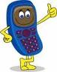



atau

atau

Fig. 9 Data flow diagram of a live city maps

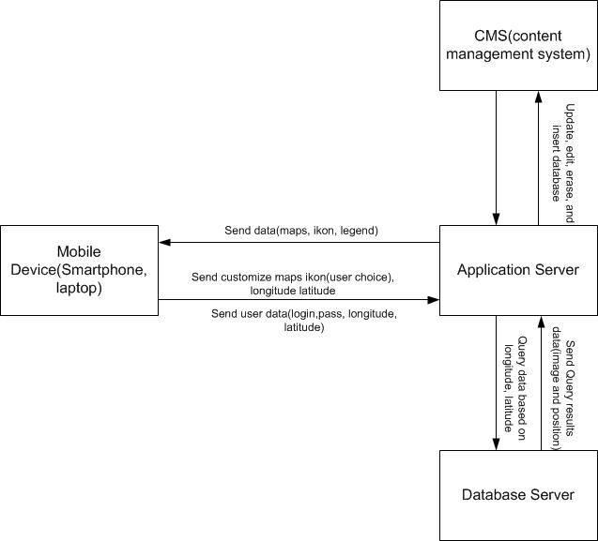

Fig. 10 The system architecture developed

The following are the modules live city map.  
  
1. Mobile module

-. Get GPS location  
-. Get Phone ID, SSID, login name and pass  
-. Sending to server  
-. Rendering /view maps

2. Module server

-. Receiving a GPS location  
-. Mapping and view it maps into

3. Module maps

-. General places like hospital, mall, gas station  
-. Public transportation like trains, buses, taxi  
-. Specific icons like home, tree, car, bicycle

Tools needed include  
1. Server  
2. Mobile (GPS and Internet)  
3. GPS module and the Internet (for further development)

Fig. 9 Prototype of Actual Mobile Application for Tourist Guide

1. CONCLUSION

Until now this has been realized a map that will be used in making the application Actual Mobile Application for Tourist Guide. Actual prototype of Mobile Application for Tourist Guides are being developed. It is hoped that a fuller realization can be completed within a time not too long.

ACKNOWLEDGMENT

Thanks to School of Electical Engineering and Informatics, Institut Teknologi Bandung as the organizers ICEEI 2011 that has given us the opportunity to contribute.

ReferenceS

[1] Jonathan Mooser, Lu Wang, Suya You and Ulrich Neumann, *An Augmented Reality Interface for Mobile Information*.

[2] Thomas Bakken, An evaluation of the SIFT algorithm for CBIR, in *Telenor R&I Research Note 30/2007*.

[3] G.D Ramkumar, *Image recognition as a Method for Opt-in and Applications for Mobile Marketing*, SnapTell White Paper.

[4] Lowe, David G., Object Recognition Using SIFT, *Proc. of the International Conference on Computer Vision*, Corfu, September, 1999.

[5] Braitner, Michael., Market Development of Mobile Device Classes and Operating Systems, *Seminar On Mobile Business*, Institute for Information Systems Research LV 71407 Winter term 2006/2007.